Imaging Clinical Research Facility
DIVISIONAL

Standard Operating Procedure

Management of BMEIS research databases

This document describes the procedures that apply to the design, development & support of research databases within the school of Biomedical Engineering and Imaging Science (BMEIS)

Document Detail
Parent policy | N/A
Document location
Version | V0.4
Reviewed by | Cuong Lau
Approved by
Effective from
Date last reviewed
Date of next review
Owner
Author | Michael Waring, Josef Habib
Superseded documents
Related documents
Keywords

Document History
Date | Comments | Approved by

Table of Contents
Table of Contents 2
Introduction 2
Aim 2
Database Development Lifecycle 2
Roles and Responsibilities 3
Appendices 6
Appendix 1 – BMEIS Development Flowchart 6
Appendix 2 – Data Management Document Templates 7
Appendix 3 – GDPR Definition of Pseudonymisation 8

Introduction

The purpose of this procedure is to provide clear standardised guidance on how BMEIS databases should be designed, developed and maintained. Responsibilities are clearly defined for each step in the procedure.

Aim

This procedure outlines a framework to ensure that new research databases within the school of Biomedical Engineering and Imaging Science are robust, secure, aligned with best practices and are in full compliance with all relevant regulatory requirements (such as the Data Protection Act 1998) as well as local data protection and confidentiality procedures. Adherence to this procedure is a pre-requisite for database provision within the school.

Database Development Lifecycle

Good database design should broadly follow the following lifecycle:

Phase | Description
Requirements gathering | Collecting all the questions and requirements from users and clients | 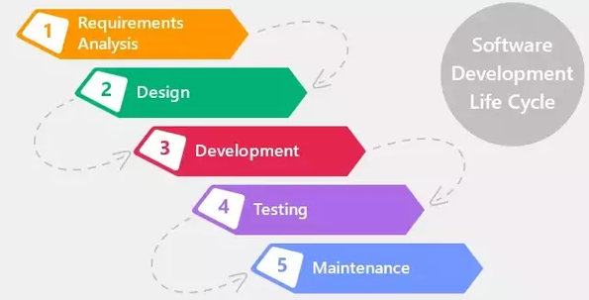
Database design  (to be signed off) | Development of the software specification document
Development/  Implementation | Developing the database in line with the specification
Testing | Testing the software, finding bugs and fixing them
Deployment and maintenance | Putting the software into use and maintaining it, fixing errors if they occur

A step by step flowchart can be found in Appendix 1, which outlines the sequence of specific steps as well as the involvement of the key stakeholders at each stage.

Roles and Responsibilities

Chief/Principal Investigator
The chief/principal investigator should designate one or more primary users to make initial contact with, and liaise with the database management team (DMT). This would normally be a project manager or study coordinator. The chief/principal investigator can then delegate responsibility for the following tasks to that designated individual.

The chief investigator is strongly encouraged to contact the DMT early on in the study design process. An email should be sent to BMEIS_DataManagementTeam@kcl.ac.uk requesting an initial meeting for the research team to discuss the project with the DMT. For any study using case report forms (CRFs) the chief investigator should consult with the DMT (for guidance on the design and coding). Where CRFs are to be utilised, a draft version must be agreed within the research team and provided to the DMT prior to being sent to the Ethical Approvals Committee.

The Chief/Principal Investigator is responsible for approving the various key documents associated with the database:
- Case Report Form (CRF)
- Data Management Plan (DMP)
- Requirements Specification Document (RSD)
The approval should be documented using the BMEIS study database documentation approval form. All key document templates are available from the DMT.

For study databases which require access outside of the KCL computer network, the Chief Investigator must advise the DMT as early as possible. External facing databases require written approval from KCL IT Services and more information may be required in order to facilitate this.

The Chief/Principal Investigator will provide details of authorised data entry staff and other staff that need access to any databases and ensure that resources are available to provide training to them. A new user request form template will be provided (Appendix 2) which will facilitate such requests and provide a log for individual staff training. Where a test version of the database is available, trained users will be provided with test accounts, and they will be expected to enter test data into the test version which needs to be checked prior to the closure of the test account and the issuance of the live account. It is also the responsibility of the Chief/Principal Investigator to inform the data management team when staff accounts require deactivation (for example when staff leave).

At the completion of the study, when all data has been entered and any queries resolved, the Chief/Principal Investigator must initiate the closure of the database by contacting the DMT in writing as part of study closure. Database closure involves removal of all user write access to the database (meaning no further changes can be made) and is defined as “locking” the database. Data extracts can only be considered final and complete once the database has been locked. Initially, locks can be “soft” meaning that they are reversible upon written request of the Chief Investigator if further queries arise during analysis. This is sometimes referred to as “freeze”. Once analysis has been completed, a hard lock can be implemented which requires Chief/Principal Investigator sign off and adherence to a more formal and documented procedure to unlock.

Database Management Team (DMT)
The DMT will draft a Data Management Plan. This is to provide an outline of the data management specifics to the proposed study, and will need to be signed off by the Chief/Principal Investigator. This should utilise the BMEIS Data Management Plan template (Appendix 2), and include details around personnel, milestones, data queries, security, data backup, amendments, database closure and archiving. As the study progresses, the Data Management Plan may evolve, being updated and re-versioned as appropriate to reflect any changes in study design. However, a first version should be agreed and signed off prior to release of the production database.

The DMT will draft and coordinate the development of a study specific BEIS Requirements Specification Document (Appendix 2) that will be used to gather all the functional requirements (sites, events, forms, fields) for the new study database, with input from the CI (or named deputy). This document will include a table of fields covering:

- All data items to be captured.
- Validations that should be performed upon data entry
- Calculations or other processing that the system should perform
- Reports or other forms of output that the system should produce.

Note that this document needs to be signed off by both DMT and research team prior to any development taking place.

The DMT will develop the study database based on the requirements specified in the document. They will be responsible for implementing system security and user access control, and ensure that the system is appropriately tested internally within the development team to ensure that it meets the design requirements before making it available for user testing or any other system validation.

The DMT will release the study database for user acceptance testing, and train and assist end users as required during testing. Once user acceptance testing is completed, they will deploy the developed study database into production. At the point of issuing the production login, any test database access would be removed to ensure that there is no confusion about test and live accounts.

The DMT will provide first line support to primary users in the event that it is required. All correspondence should be directed to BMEIS_DataManagementTeam@kcl.ac.uk

Research Team
The research team will liaise with the DMT to assist in completion of the study data management plan and the study requirement specification document. Wherever possible, data should be appropriately pseudonymised (see Appendix 3) to protect personal and confidential data.
Once the database has been developed and is ready for user testing, the research team will complete a full test of all of the functionality outlined in the study requirement specification document under the guidance of the DMT, who will provide detailed training on how to complete and document this.
The research team will complete a brief study specific user guide for the study database. For databases using standardised platforms (e.g. REDCAP), a template document will be provided by the DMT (Appendix 2)

The research team will complete data entry according to instructions and timely fashion and when using paper CRFs, sign or initial (as appropriate) and date each CRF once entry is completed.

Appendices

Appendix 1 – BMEIS Development flowchart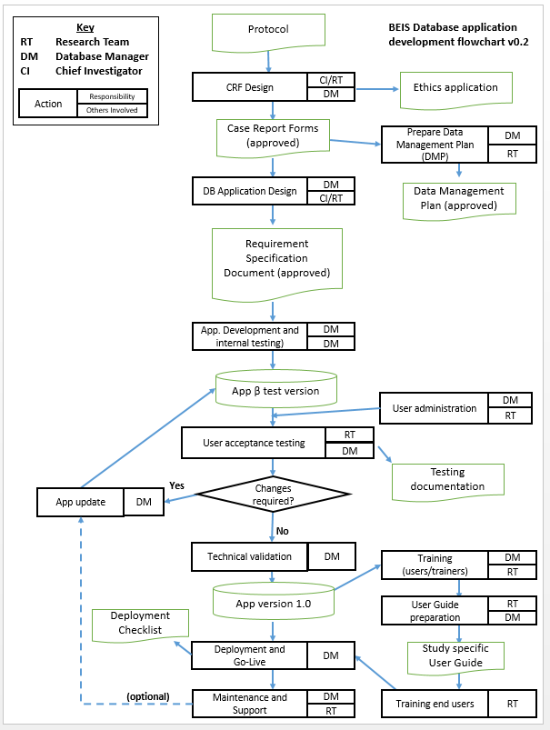A

Appendix 2 – Data Management Document Templates

BMEIS Data Management Plan template
BMEIS Database New User Request Form
BMEIS Requirements Specification Document
BMEIS REDCAP User Guide template

Appendix 3 – GDPR Definition of Pseudonymisation

‘Pseudonymisation’ means the processing of personal data in such a manner that the personal data can no longer be attributed to a specific data subject without the use of additional information, provided that such additional information is kept separately and is subject to technical and organisational measures to ensure that the personal data are not attributed to an identified or identifiable natural person. The result of pseudonymisation is pseudonymised data which remain personal data but being protected through coding or encryption. Throughout the GDPR, the use of pseudonymisation is promoted and shall be implemented, as far and as soon as possible, in personal data processing for scientific research purposes, as a standard data protection practice.

https://www.quora.com/What-is-SDLC-How-we-can-explain-our-project-with-SDLC
Article 4(5) and Recitals 26 and 28 of the GDPR

